

WorkSpace

Secure File Transfer System

User Guide
Secure File Transfer System via Email
Virginia Community College System (VCCS) faculty and staff have a new method for sending and receiving files containing sensitive information or for sending and receiving files regardless of size or format. VCCS policy 6.0.10.4 requires colleges use a secure site and login procedures to send legally required, personally identifiable, or FERPA-protected information. Workspace should be used instead of email any time you need to send sensitive data to another VCCS faculty staff, and external recipients. Workspace is a secure file transfer system for person-to-person email communication. The Workspace is accessible online.
Workspace offers a simple, secure, and central file sharing method between the employees of VCCS 23 community colleges, Shared Services Center, and the System Office. Workspace allows employees to invite VCCS and 23 community college users to share folders and their content. The Workspace includes multiple secure protocols, flexible authentication, leveraging the highest levels of security, regulatory compliance, authentication, and data encryption aspects of the Electronic File Transfer platform.

Key Results:
- Share folders and their files securely between employees.
- Send secure messages and attachments without file type or size limitations, in a secure drop-off portal.
- Send files securely from your browser with just an email address
- Generate reports of Workspaces activity to gain immediate visibility into who shared what with whom.

website.

Accessing Workspace Online
- From the myVCCS portal click the WorkSpaces icon
- Or navigate to the URL: workspace.vccs.edu
- myVCCS username and password are required. Employees and faculty members will use their same credentials when they login to the college website.
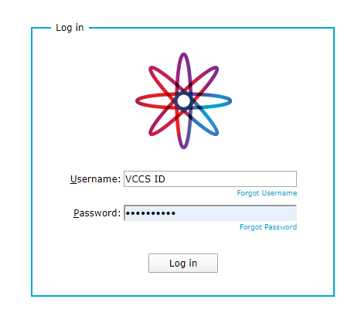
- Users have the following options for sending and sharing files:
- Sending files to VCCS and non-VCCS recipient(s). See page 4.
- Sharing a folder allows a sender and VCCS recipients to share, add, edit, and upload files to the same folder. See page 5.
- External recipients may send files to VCCS employees. See page 10.

Sending files to VCCS and non-VCCS recipient(s).
- To send files to recipient(s), click on "Send Files."
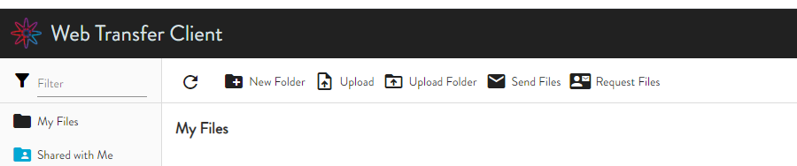

Input the following information:
- Recipient(s) email address
- Enter a Subject line
- Compose Message
- Drag and drop files
- Select a message Delivery Options such the expiration date
- Once complete, Send Message.

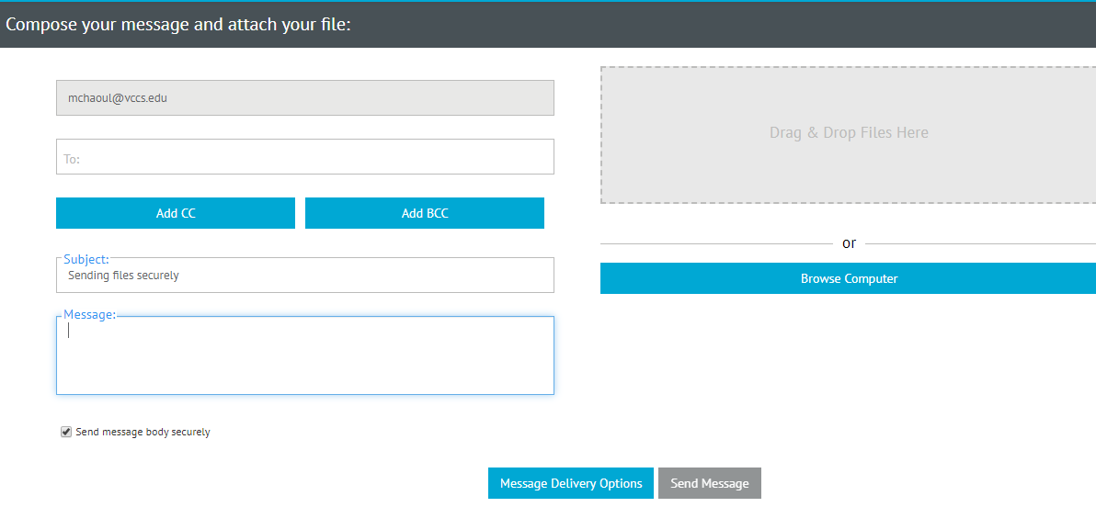

To share a folder
- Under folder name, type the name of the new folder, then click "Create."
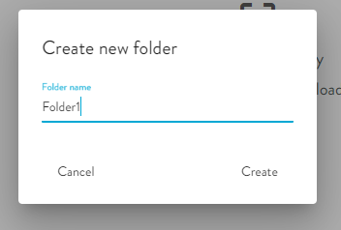

- A new folder, "Folder1," will appear in the list.
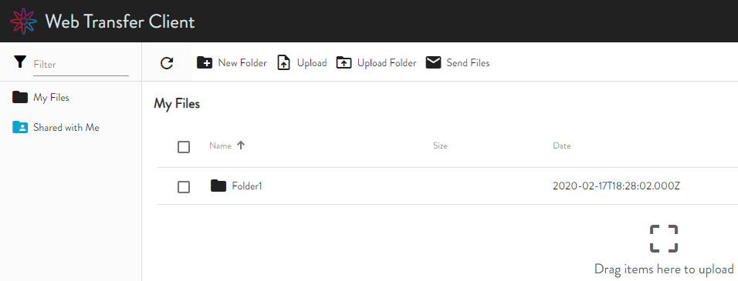

- Add Files, Drag, and drop file(s) into the folder you plan to share.

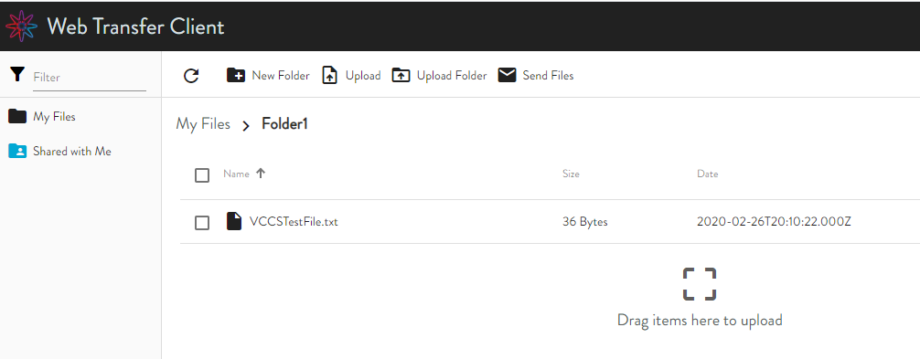

- Once all files are uploaded, click on "My Files" to see all folders created.
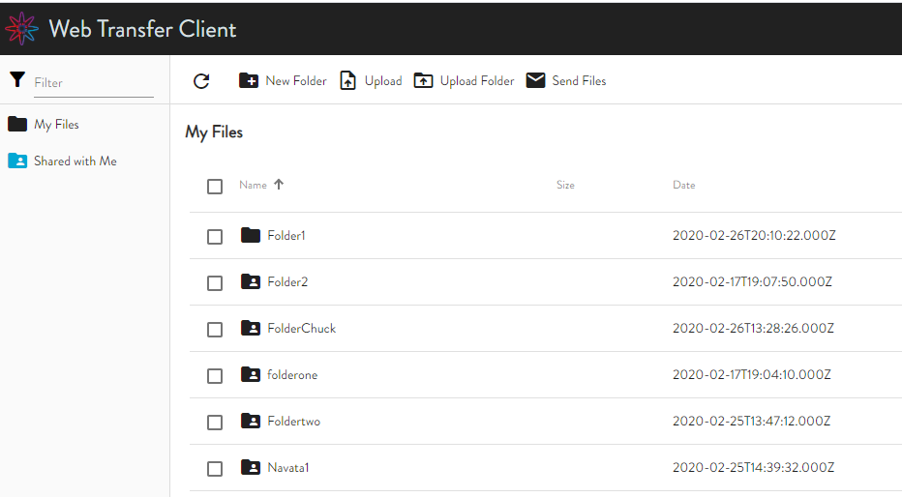

- Select the folder to share by clicking on the folder's name.
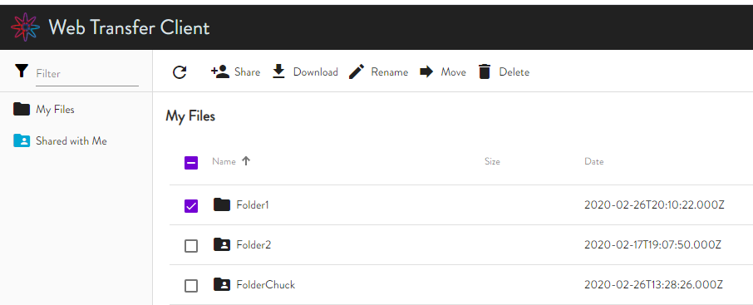

- Select the Share Icon at the top of the page.
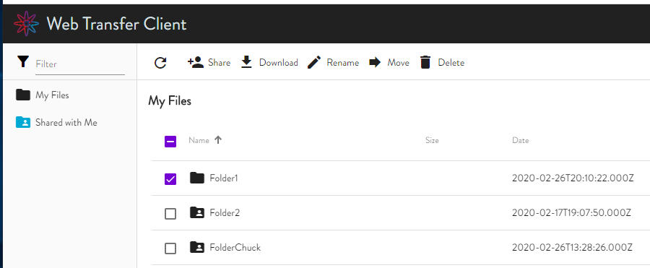

- Under Recipients, type the email address of the receiving person(s).
Note: Workspace uses the VCCS email address (@email.vccs.edu) as specified in the employee's SIS record.
Recommendations-confirm with recipient(s) their VCCS email address to ensure receipt of file(s).
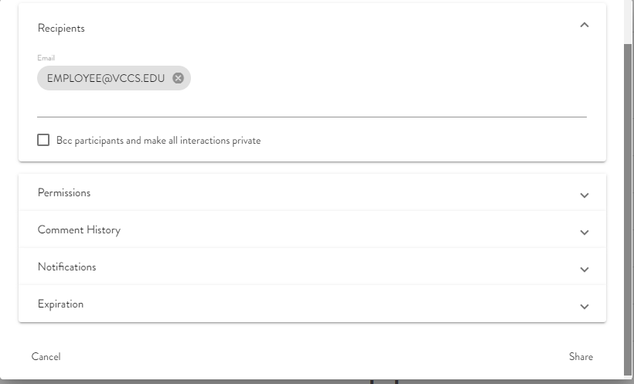
The navigation to verify this in SIS is Self Service > Student Center. On the bottom left of the page, change the drop-down from Other Personal to Email Address and click >> the VCCS email as noted here.

- Permissions: Select the access level by checking the Permission boxes to choose what access the recipients should have when receiving the file(s). By default, all permissions checked.

Note: Choosing option "Upload" allows any recipient to add more files to the received folder which could be shared with all parties (sender and recipients).
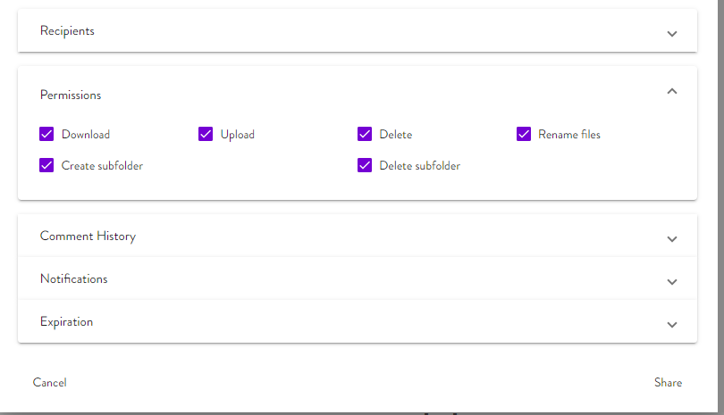
- Compose Message.
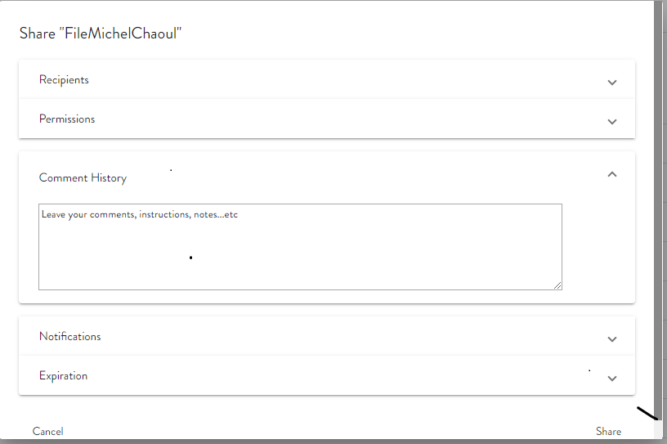

- Notifications: Sender may select the kinds of updates, progress, and status of files sending. You can get notifications when the files were downloaded, uploaded, deleted, …etc.

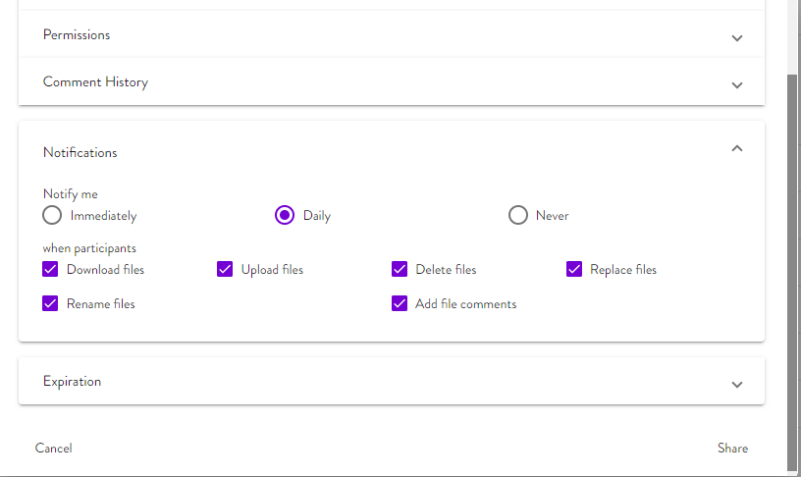

- Expiration: by default, the expiration date is one month from the date file(s) are sent. The sender may change the expiration date for up to 5 years.

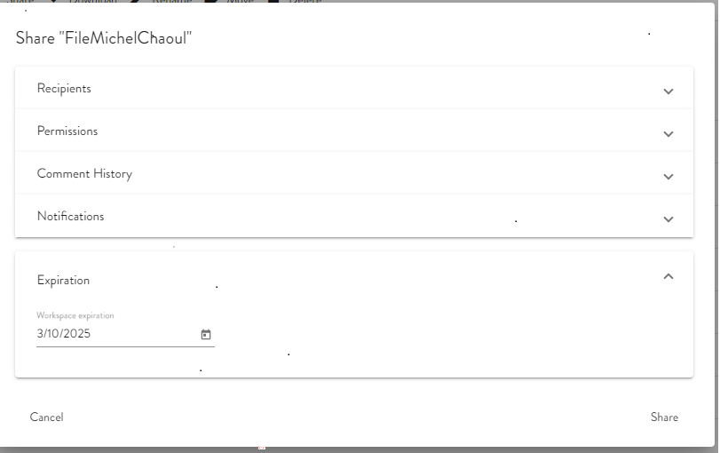

When ready, click Share.

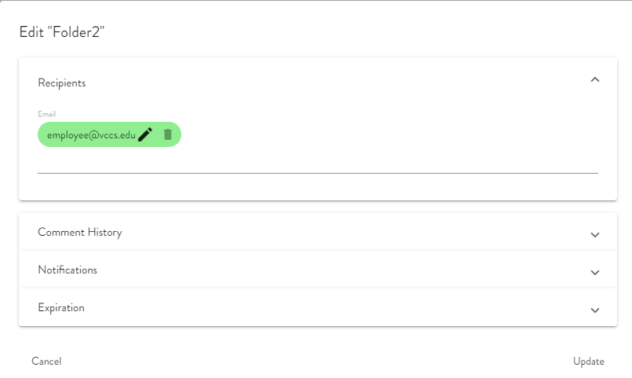

III. External recipients to send files to VCCS employees
Vendors and external recipients will be able to send files to VCCS employees. This process starts by VCCS employees sending a Request to external and non-VCCS recipients. Recipient would receive an invitation to a URL to drop off the files.

- Logon to workspace.vccs.edu and click on the "Request Files" button.
- Fill in the required fields and click on "Send Request"
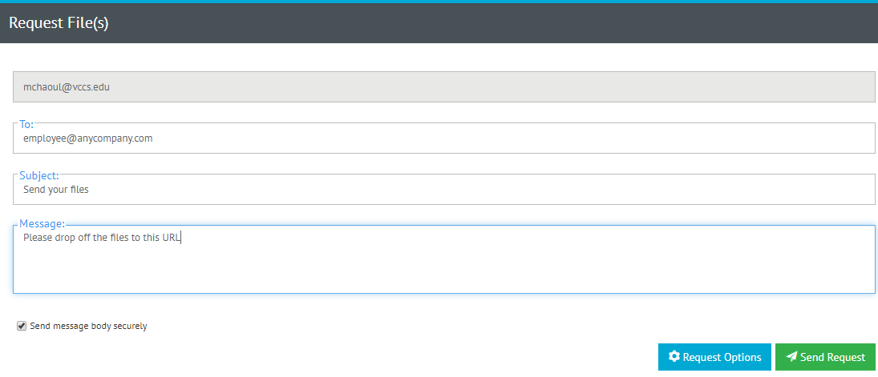

- The recipient will receive an invitation to drop off the files, as shown below:

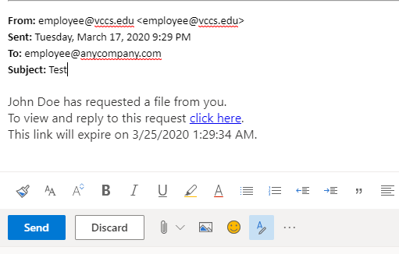

How Recipients Retrieve Files
VCCS Recipient(s) receive an email note when files are shared with them. They must use their myVCCS username and password to access the Message.

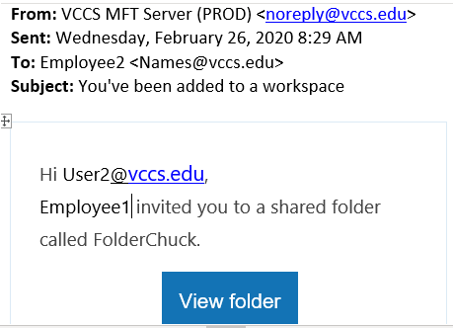

As a sender, you will receive a receipt when your recipients accessed secured files or downloads any of the shared files.

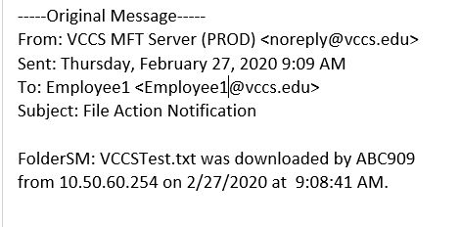

Frequently Asked Questions

Q: Who can use Workspace?

A: Any active employee or faculty in the VCCS active directory and has a VCCS email address. VCCS active directory contains the emails of all VCCS, Shared Services, and 23 college employees and faculties.

Q: What email account is used with Workspace?

A: Workspace uses your VCCS email that is set in SIS. To check this, log in to SIS. Navigate to Self Service > Student Center at the bottom left of the page, where the drop-down shows other personal.

Q: What credentials do I use to log in to Workspace?

A: Use your college, myVCCS username and password, the same credentials you would use to log in to your college website.

Q: Can I store files using Workspace?

A: Workspace's Secure File Transfer is used to send and receive files; however, it is not a file storage service. Files are automatically removed from the server when the links expire.

Q: How do I forward my VCCS Student Gmail to Work Email?

A: View as a web page.

For support, contact VCCS ITS at https://vccs.teamdynamix.com/TDClient

